Blossom Watch 2021

Alan Millington

2021-03-22 11:56:10

|  |  |
| --- | --- |
| hashtag | count |
| blossom | 1801 |
| blossomwatch | 1244 |
| NationalTrust + BlossomWatch | 31 |
| EveryoneNeedsNature | 180 |
| None | 1386 |

# Timeline

## Tweets by day

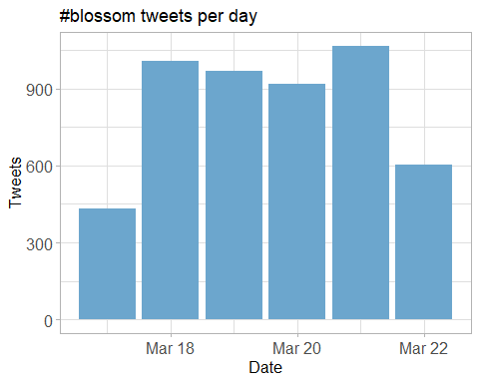

## Tweets by day and time

Filtered for dates March, London time. 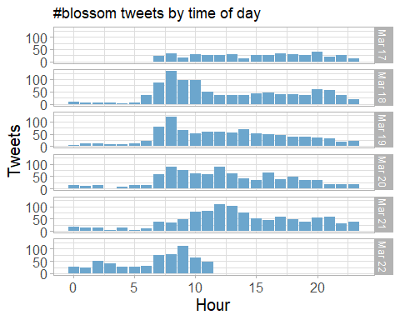

# Users

## Top tweeters

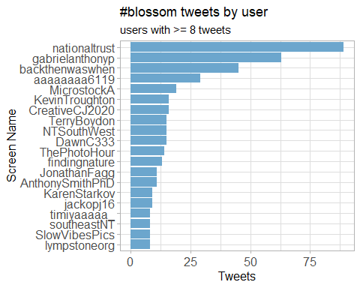

## Sources

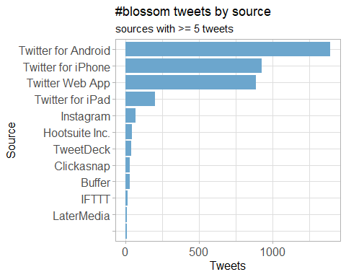

# Networks

## Replies

The “replies network”, composed from users who reply directly to one another.

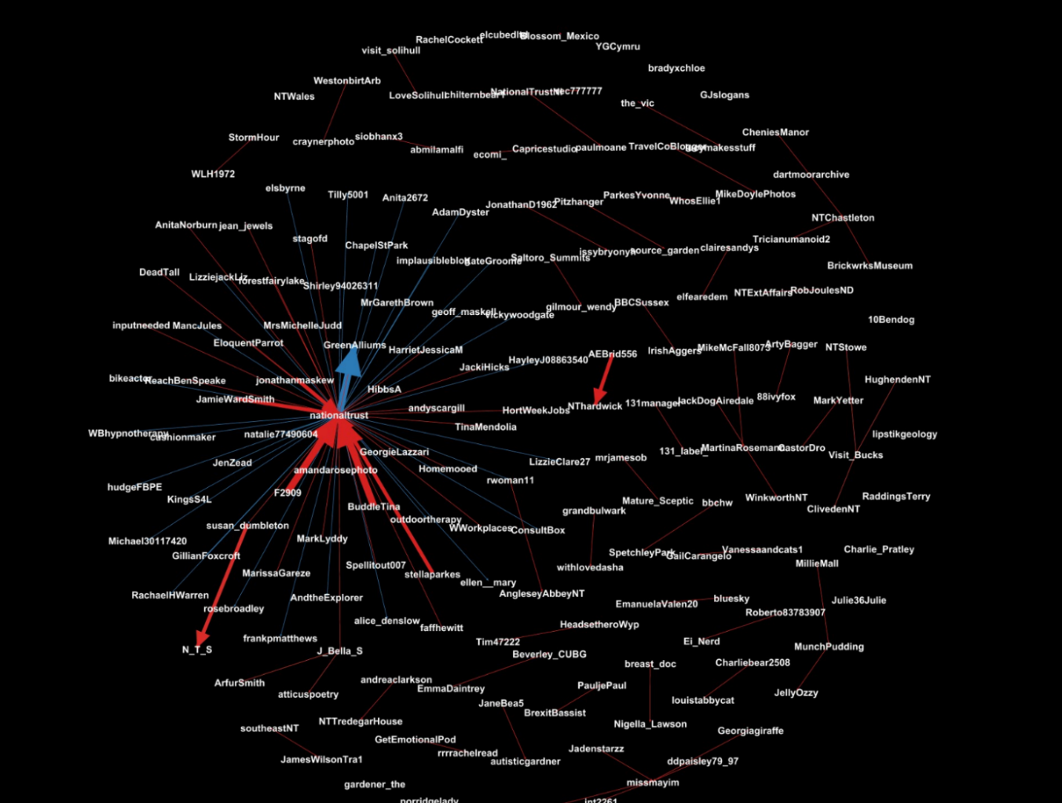

## Mentions

The “mentions network”, where users mention other users in their tweets.



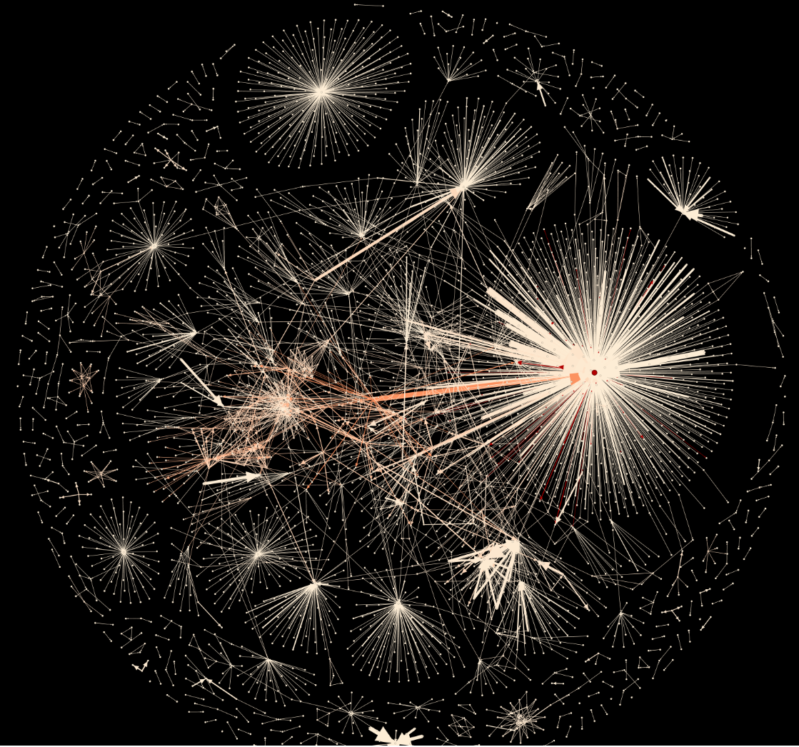

# Retweets

## Retweet proportion

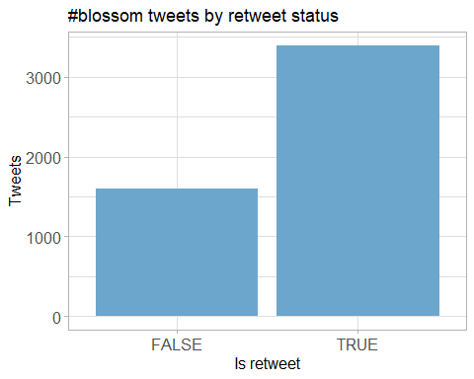

## Retweet count

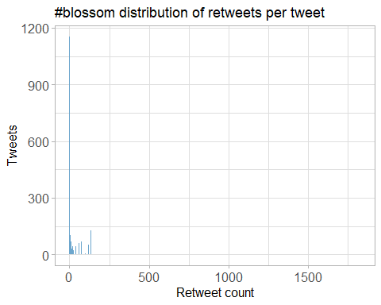

## Top retweets

|  |  |  |
| --- | --- | --- |
| screen_name | text | retweet_count |
| KhushnumaKashm1 | Spring in #Kashmir #Almond #Blossom <https://t.co/rIPIIJmHST> | 466 |
| nationaltrust | Pause to soak up the sweet scents and soft songs emanating from blossom branches. These colourful trees are a feast for the senses. #BlossomWatch <https://t.co/GsXfF5KPAE> | 236 |
| DrDarrenRFlower | Central Park New York #spring #spring2021 #blossom #cherry <https://t.co/Oimq2hRU1k> | 135 |
| nationaltrust | Everywhere these delicate flowers emerge, they bring delight with them. Thanks to everyone who’s helped spread the joys of blossom so far - keep the photos coming with #BlossomWatch. Photos: Joanna A, Catherine A, Shonali B, Cara W. <https://t.co/6znNDEdvKC> | 121 |
| nationaltrust | <U+0001F338>#BlossomWatch<U+0001F338> Lockdowns have changed the nation’s relationship with nature for the better. We are feeling more connected thanks to our daily strolls and taking more notice of the changing seasons. <https://t.co/JtIkqgUorV> | 91 |
| nationaltrust | Happily dancing in the breeze, a golden daffodil is full of cheer. #EveryoneNeedsNature <https://t.co/hSOWdCCnPL> | 75 |
| nationaltrust | One of life’s simple pleasures that can be enjoyed from anywhere. Engross yourself in the calming colours of a sunrise. #EveryoneNeedsNature <https://t.co/l5xkDICUPn> | 68 |
| ampomata | This is my new painting “Bed Of Roses”. You can check it out here: <https://t.co/GoYnqeM1YY> #art #arte #oleo #kunst #oilpainting #contemporaryart #ArtistOnTwitter #blossom #flower #floral #spring #pink #red #roses #field #artprints #flowers #garden <https://t.co/7y9skbUaMs> | 67 |
| MikeDoylePhotos | Spring colour at Sheffield Park, East Sussex. #Sussex #England #NationalTrust #landscape #landscapephotography #travel #travelphotography #photo #photography #photooftheday #NaturePhotography <https://t.co/uFdcfnor39> | 60 |
| MikeDoylePhotos | Early autumn at Sheffield Park, East Sussex. #Sussex #England #NationalTrust #landscape #landscapephotography #travel #travelphotography #photo #photography #photooftheday #NaturePhotography <https://t.co/fqSC6f0xMQ> | 57 |

# Favourites

## Favourite proportion

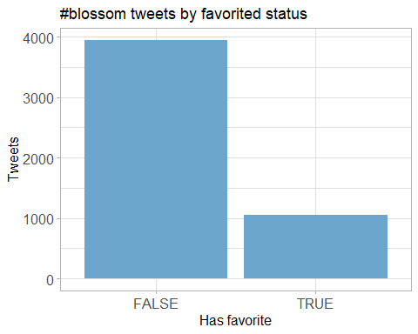

## Favourite count

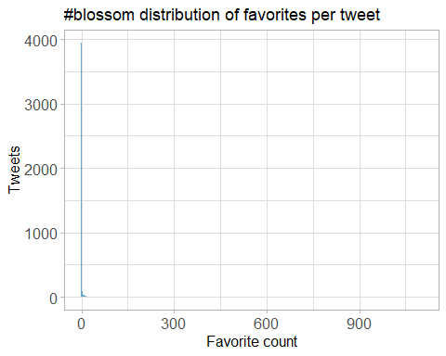

## Top favourites

|  |  |  |
| --- | --- | --- |
| screen_name | text | favorite_count |
| nationaltrust | Pause to soak up the sweet scents and soft songs emanating from blossom branches. These colourful trees are a feast for the senses. #BlossomWatch <https://t.co/GsXfF5KPAE> | 1102 |
| DrDarrenRFlower | Central Park New York #spring #spring2021 #blossom #cherry <https://t.co/Oimq2hRU1k> | 735 |
| nationaltrust | Everywhere these delicate flowers emerge, they bring delight with them. Thanks to everyone who’s helped spread the joys of blossom so far - keep the photos coming with #BlossomWatch. Photos: Joanna A, Catherine A, Shonali B, Cara W. <https://t.co/6znNDEdvKC> | 690 |
| nationaltrust | <U+0001F338>#BlossomWatch<U+0001F338> Lockdowns have changed the nation’s relationship with nature for the better. We are feeling more connected thanks to our daily strolls and taking more notice of the changing seasons. <https://t.co/JtIkqgUorV> | 560 |
| KhushnumaKashm1 | Spring in #Kashmir #Almond #Blossom <https://t.co/rIPIIJmHST> | 525 |
| MikeDoylePhotos | Early autumn at Sheffield Park, East Sussex. #Sussex #England #NationalTrust #landscape #landscapephotography #travel #travelphotography #photo #photography #photooftheday #NaturePhotography <https://t.co/fqSC6f0xMQ> | 461 |
| MikeDoylePhotos | Spring colour at Sheffield Park, East Sussex. #Sussex #England #NationalTrust #landscape #landscapephotography #travel #travelphotography #photo #photography #photooftheday #NaturePhotography <https://t.co/uFdcfnor39> | 431 |
| nationaltrust | Happily dancing in the breeze, a golden daffodil is full of cheer. #EveryoneNeedsNature <https://t.co/hSOWdCCnPL> | 418 |
| nationaltrust | One of life’s simple pleasures that can be enjoyed from anywhere. Engross yourself in the calming colours of a sunrise. #EveryoneNeedsNature <https://t.co/l5xkDICUPn> | 407 |
| MikeDoylePhotos | A view of the Middle Lake at Sheffield Park, East Sussex. #Sussex #England #NationalTrust #landscape #landscapephotography #travel #travelphotography #photo #photography #photooftheday #NaturePhotography <https://t.co/HAeeTUTOI4> | 393 |

# Quotes

## Quote proportion

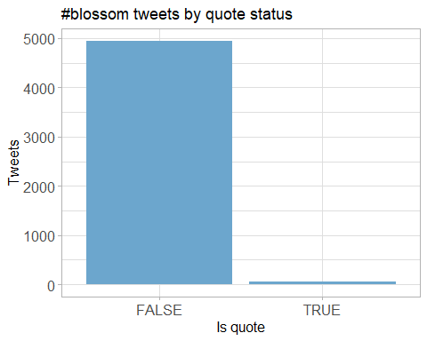

## Quote count

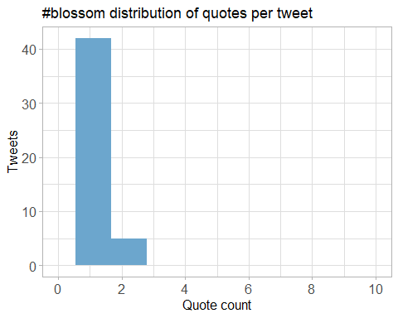

## Top quotes

Joining, by = “quoted_status_id”

|  |  |  |
| --- | --- | --- |
| screen_name | text | quote_count |
| weather2travel | Will you be joining @nationaltrust #BlossomWatch? <U+0001F338><U+0001F440> #thursdaymorning #ThoughtForTheDay #spring #bliss <https://t.co/aiQYIY1n5N> | 2 |
| HeiniHeikkil | Mesmerising, refreshing blossom shared by millions in social media <U+0001F338>#UKhanami #BlossomWatch <https://t.co/Ut9p5H0aEL> | 2 |
| NaturalEngland | Our research shows that nature is more important than ever to us since the pandemic started. We’re taking more notice of small changes in nature and signs of spring, like beautiful apple blossom. Share your pictures of blossom with @NationalTrust using <U+0001F338>#BlossomWatch <U+0001F338> <https://t.co/KlDTIYa46E> | 2 |
| radiowinch | Spring is on the way. Celebrate the arrival of blossom near you with #BlossomWatch share your photos <https://t.co/B0TuHmf6Sk> | 2 |
| LauraSkitt_ | I love blossom trees so much. It reminds me spring is nearly here which means my birthday is nearly here (end of April, but still!) #BlossomWatch <U+0001F338> <https://t.co/gB9yiEInEo> | 2 |
| sheffieldparkNT | Here at @Nationaltrust we are celebrating the delicate clusters of flowers that are starting to appear on the trees- #blossomwatch is here! Have you spotted any blooms festooning the trees? Share your pics on our blossom map with #BlossomWatch <https://t.co/Uk6EYfJsV4> <https://t.co/T1QMKLUHwo> | 2 |
| DerbyUniPress | Research @DerbyUni is making important contributions to initiatives designed to enhance our #wellbeing and strengthen our relationship with #nature, such as @nationaltrust #BlossomWatch, which has been launched today. @findingnature <https://t.co/c4ZAhGJs1Q> | 2 |
| MiriamDobson | Great blog & paper! #BlossomWatch is such a fantastic opportunity to engage with moments in nature - these simple moments of noticing are so important for wellbeing (as this research demonstrates!) <https://t.co/pBwUoaQ3ZS> | 2 |
| AdamDyster | Really excited to have kicked this off today - and looking forward to seeing MPs’ #BlossomWatch pictures from all over the country <U+0001F338> We definitely need a dose of hope & beauty right now- and nature’s providing that on our doorstep! <https://t.co/y2GsraWems> | 2 |
| heritage_lizzie | Itâ€™s time for #BlossomWatch @nationaltrust <U+0001F333> <https://t.co/PnZ35hHU4R> | 2 |

# Media

## Media count

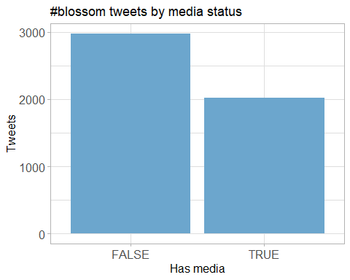

## Top media

|  |  |  |
| --- | --- | --- |
| screen_name | text | favorite_count |
| nationaltrust | Pause to soak up the sweet scents and soft songs emanating from blossom branches. These colourful trees are a feast for the senses. #BlossomWatch <https://t.co/GsXfF5KPAE> | 1102 |
| DrDarrenRFlower | Central Park New York #spring #spring2021 #blossom #cherry <https://t.co/Oimq2hRU1k> | 735 |
| nationaltrust | Everywhere these delicate flowers emerge, they bring delight with them. Thanks to everyone who’s helped spread the joys of blossom so far - keep the photos coming with #BlossomWatch. Photos: Joanna A, Catherine A, Shonali B, Cara W. <https://t.co/6znNDEdvKC> | 690 |
| nationaltrust | <U+0001F338>#BlossomWatch<U+0001F338> Lockdowns have changed the nation’s relationship with nature for the better. We are feeling more connected thanks to our daily strolls and taking more notice of the changing seasons. <https://t.co/JtIkqgUorV> | 560 |
| KhushnumaKashm1 | Spring in #Kashmir #Almond #Blossom <https://t.co/rIPIIJmHST> | 525 |
| MikeDoylePhotos | Early autumn at Sheffield Park, East Sussex. #Sussex #England #NationalTrust #landscape #landscapephotography #travel #travelphotography #photo #photography #photooftheday #NaturePhotography <https://t.co/fqSC6f0xMQ> | 461 |
| MikeDoylePhotos | Spring colour at Sheffield Park, East Sussex. #Sussex #England #NationalTrust #landscape #landscapephotography #travel #travelphotography #photo #photography #photooftheday #NaturePhotography <https://t.co/uFdcfnor39> | 431 |
| nationaltrust | Happily dancing in the breeze, a golden daffodil is full of cheer. #EveryoneNeedsNature <https://t.co/hSOWdCCnPL> | 418 |
| nationaltrust | One of life’s simple pleasures that can be enjoyed from anywhere. Engross yourself in the calming colours of a sunrise. #EveryoneNeedsNature <https://t.co/l5xkDICUPn> | 407 |
| MikeDoylePhotos | A view of the Middle Lake at Sheffield Park, East Sussex. #Sussex #England #NationalTrust #landscape #landscapephotography #travel #travelphotography #photo #photography #photooftheday #NaturePhotography <https://t.co/HAeeTUTOI4> | 393 |

### Most liked media image

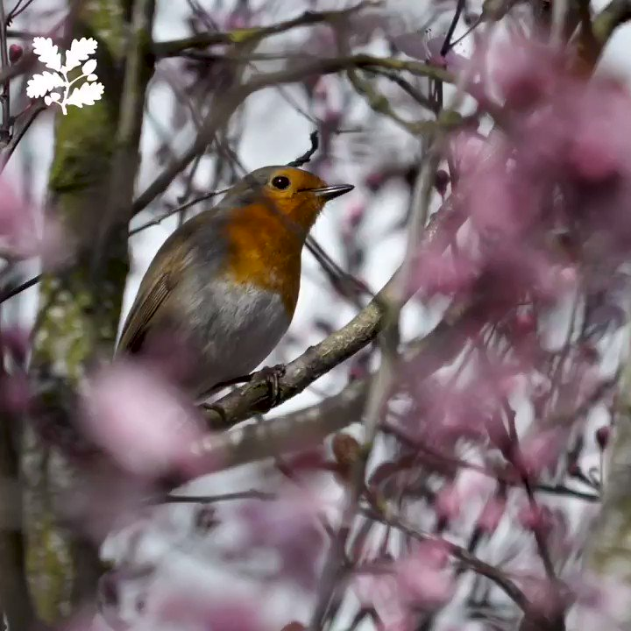

# Tweet text

The 100 words used 3 or more times.

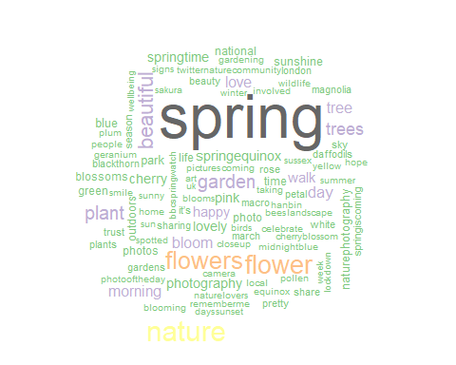

**Tweets by Tweet Length**